IT COMPANY DATABASE

Initial database:
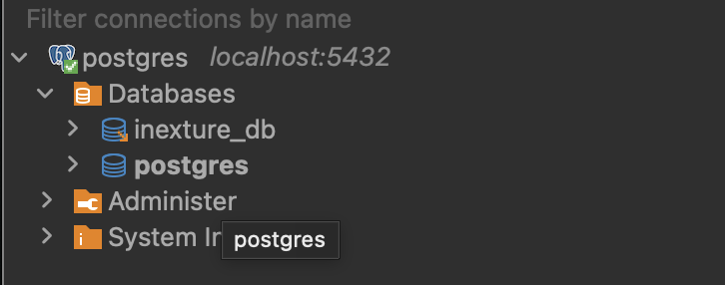
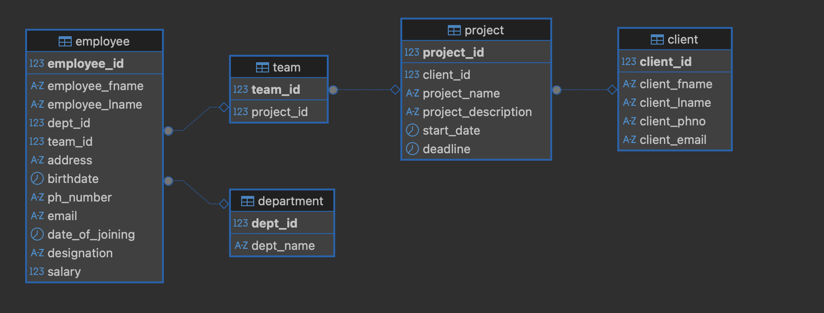

Department table:
- create table department(
dept_id int primary key,
dept_name varchar(30));

- INSERT INTO department (dept_id, dept_name) VALUES
(101, 'Human Resources'),
(102, 'Finance'),
(103, 'Sales'),
(104, 'Marketing'),
(105, 'Operations'),
(106, 'Administration'),
(107, 'IT Support'),
(108, 'Software Development'),
(109, 'Quality Assurance'),
(110, 'DevOps'),
(111, 'Cyber Security'),
(112, 'Data Science'),
(113, 'Business Analytics'),
(114, 'Product Management'),
(115, 'Project Management'),
(116, 'UI/UX Design'),
(117, 'Research and Development'),
(118, 'Cloud Engineering'),
(119, 'Networking'),
(120, 'Technical Support'),
(121, 'Team Leads'),
(122, 'Senior Developers'),
(123, 'Directors'),
(124, 'Internship Program'),
(125, 'Training and Development');



Client table

- create table client(
client_id int primary key,
client_fname varchar (50) not null,
client_lname varchar (50) not null,
client_phno varchar(20) not null,
client_email varchar(30) not null);

- INSERT INTO client (client_id, client_fname, client_lname, client_phno, client_email) VALUES
(201, 'Amit', 'Sharma', '+91-9876543210', 'amit.sharma@gmail.com'),
(202, 'Riya', 'Patel', '+91-8765432109', 'riya.patel@yahoo.com'),
(203, 'Rahul', 'Verma', '+91-9654321098', 'rahul.verma@gmail.com'),
(204, 'Neha', 'Iyer', '+91-9988776655', 'neha.iyer@gmail.com'),
(205, 'Karan', 'Mehta', '+91-9123456789', 'karan.mehta@yahoo.com'),
(206, 'Priya', 'Nair', '+91-9001122334', 'priya.nair@gmail.com'),
(207, 'Suresh', 'Reddy', '+91-8899776655', 'suresh.reddy@gmail.com'),
(208, 'Ananya', 'Sen', '+91-7766554433', 'ananya.sen@gmail.com'),
(209, 'Vikram', 'Singh', '+91-9655566778', 'vikram.singh@yahoo.com'),
(210, 'Pooja', 'Gupta', '+91-9543210987', 'pooja.gupta@gmail.com'),
(211, 'Arjun', 'Kapoor', '+91-9443322110', 'arjun.kapoor@gmail.com'),
(212, 'Mehul', 'Choksi', '+91-9332211445', 'mehul.choksi@yahoo.com'),
(213, 'Tanvi', 'Kulkarni', '+91-9223344556', 'tanvi.kulkarni@gmail.com'),
(214, 'Rakesh', 'Mishra', '+91-9112233445', 'rakesh.mishra@gmail.com'),
(215, 'Nitin', 'Aggarwal', '+91-9009988776', 'nitin.aggarwal@yahoo.com'),
(216, 'Sonal', 'Desai', '+91-8899001122', 'sonal.desai@gmail.com'),
(217, 'Mohit', 'Malhotra', '+91-8776655443', 'mohit.malhotra@gmail.com'),
(218, 'Ayesha', 'Khan', '+91-8665544332', 'ayesha.khan@yahoo.com'),
(219, 'Rohan', 'Patil', '+91-8554433221', 'rohan.patil@gmail.com'),
(220, 'Deepak', 'Yadav', '+91-8443322110', 'deepak.yadav@gmail.com'),
(221, 'Kavya', 'Rao', '+91-8332211009', 'kavya.rao@yahoo.com'),
(222, 'Siddharth','Menon', '+91-8221100998', 'siddharth.menon@gmail.com'),
(223, 'Manish', 'Jain', '+91-8110099887', 'manish.jain@gmail.com'),
(224, 'Nisha', 'Banerjee', '+91-8009988776', 'nisha.banerjee@yahoo.com'),
(225, 'Aditya', 'Raj', '+91-7998877665', 'aditya.raj@gmail.com');

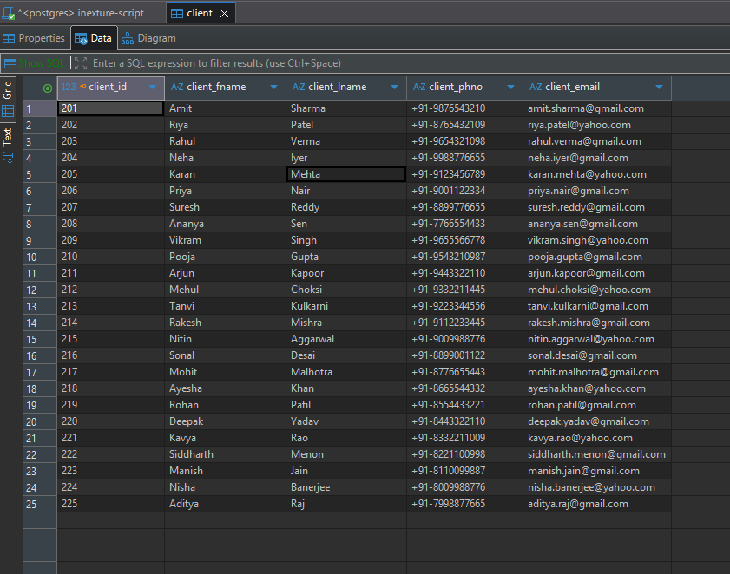

Project

- create table project(
project_id int primary key,
client_id int,
project_name varchar(50) not null,
project_description varchar(150),
start_date date,
deadline date,

constraint fk_client
foreign key (client_id)
references client(client_id)
on delete restrict
);

INSERT INTO project VALUES (301, 201, 'Website Redesign', 'Corporate website modernization', '2024-01-05', '2024-06-30');
INSERT INTO project VALUES (302, 202, 'Mobile Application', 'Android and iOS development', '2024-02-01', '2024-08-15');
INSERT INTO project VALUES (303, 203, 'ERP Deployment', 'Enterprise resource planning setup', '2024-01-20', '2024-12-10');
INSERT INTO project VALUES (304, 204, 'Cloud Migration', 'Move infrastructure to cloud', '2024-03-10', '2024-09-25');
INSERT INTO project VALUES (305, 205, 'Data Warehouse', 'Centralized data repository', '2024-02-15', '2024-11-30');
.
.
.
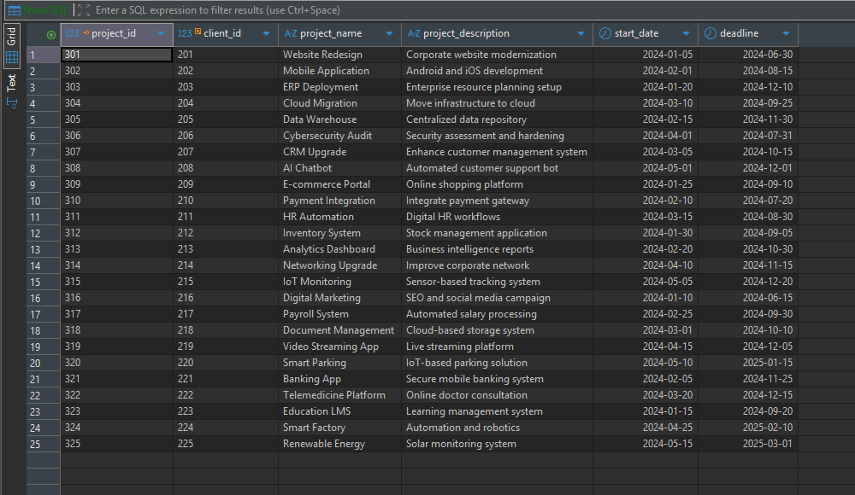

Trying to insert duplicate project_id
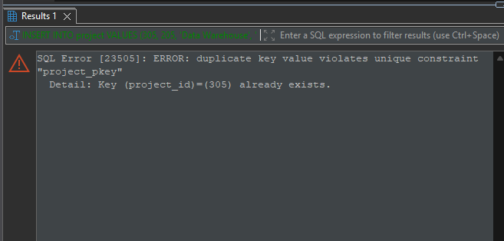

Team
- create table team(
team_id int primary key,
project_id int,

constraint fk_project
foreign key (project_id)
references project(project_id)
on delete restrict
);

Employee

CREATE TABLE employee (
employee_id INT PRIMARY KEY,
employee_fname VARCHAR(50) NOT NULL,
employee_lname VARCHAR(50) NOT NULL,
dept_id INT,
team_id INT,
CONSTRAINT fk_emp_dept
FOREIGN KEY (dept_id)
REFERENCES department(dept_id),
CONSTRAINT fk_emp_team
FOREIGN KEY (team_id)
REFERENCES team(team_id)
);
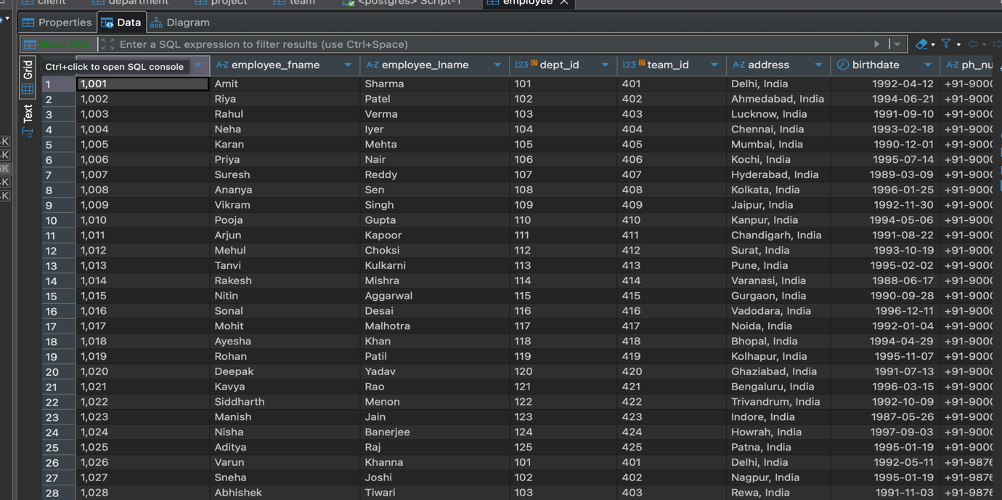

Queries performed on this database:
Basic SELECT Queries
- SELECT dept_id, dept_name FROM department;

- SELECT
client_fname AS FirstName,
client_lname AS LastName
FROM client;
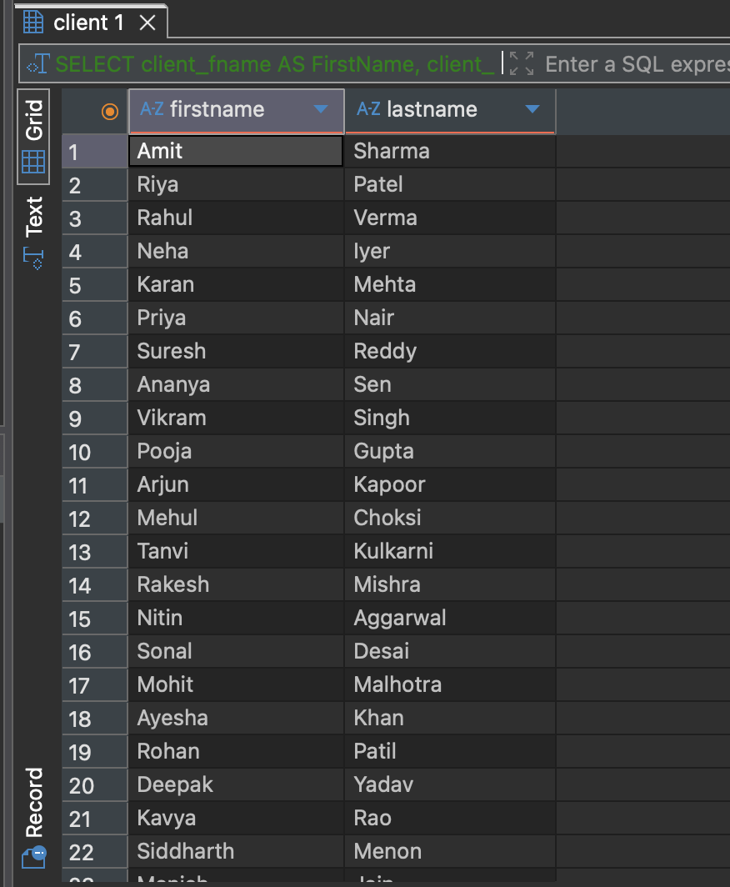

WHERE Clause (Filtering)

- SELECT *
FROM department
WHERE dept_id > 110;
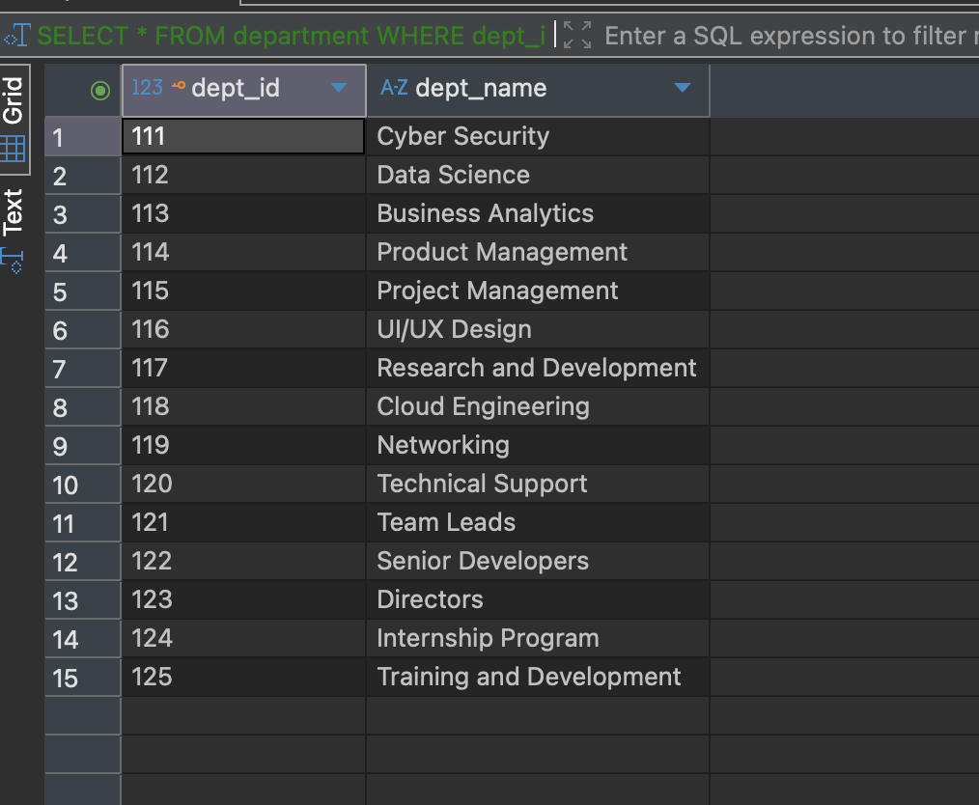

- SELECT *
FROM client
WHERE client_email LIKE '%gmail.com';

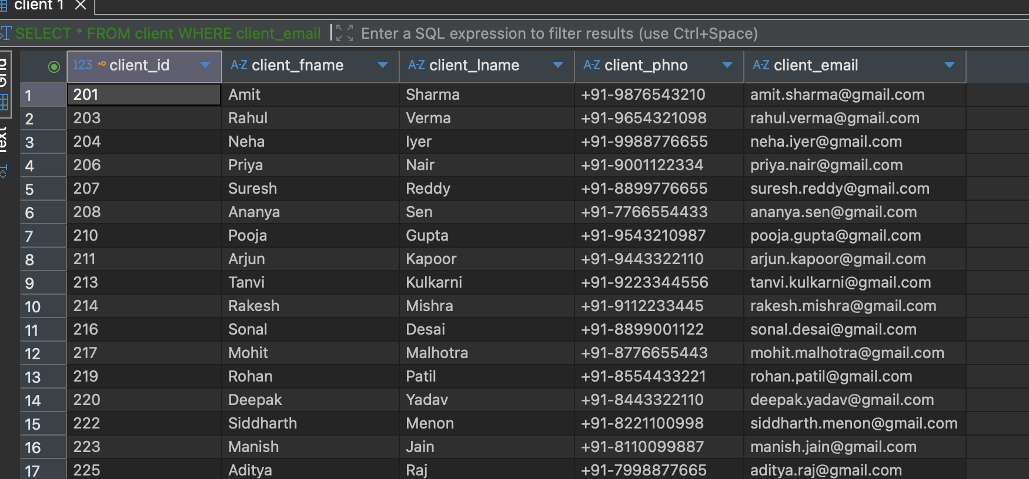

- SELECT *
FROM project
WHERE start_date BETWEEN '2024-02-01' AND '2024-03-31';



- SELECT *
FROM department
WHERE dept_id IN (101, 105, 110);

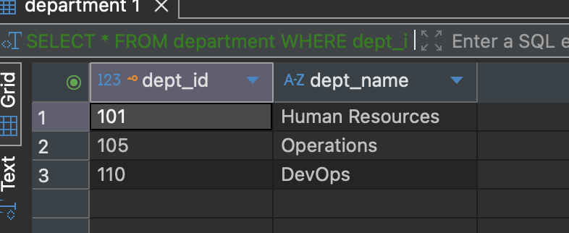

ORDER BY & LIMIT

- SELECT *
FROM client
ORDER BY client_fname ASC;

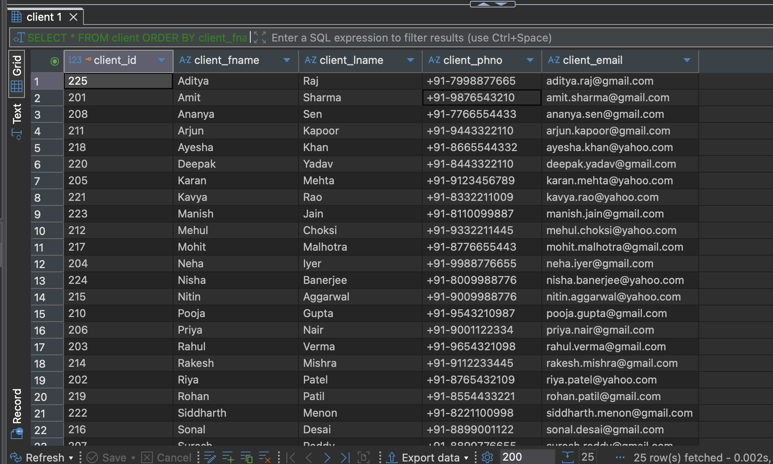

- SELECT *
FROM project
ORDER BY start_date
LIMIT 5;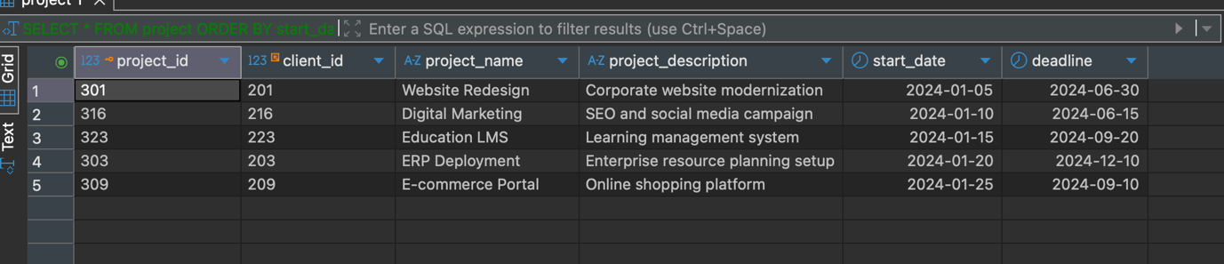

Aggregation functions

- SELECT client_id, COUNT(project_id) AS project_count
FROM project
GROUP BY client_id;

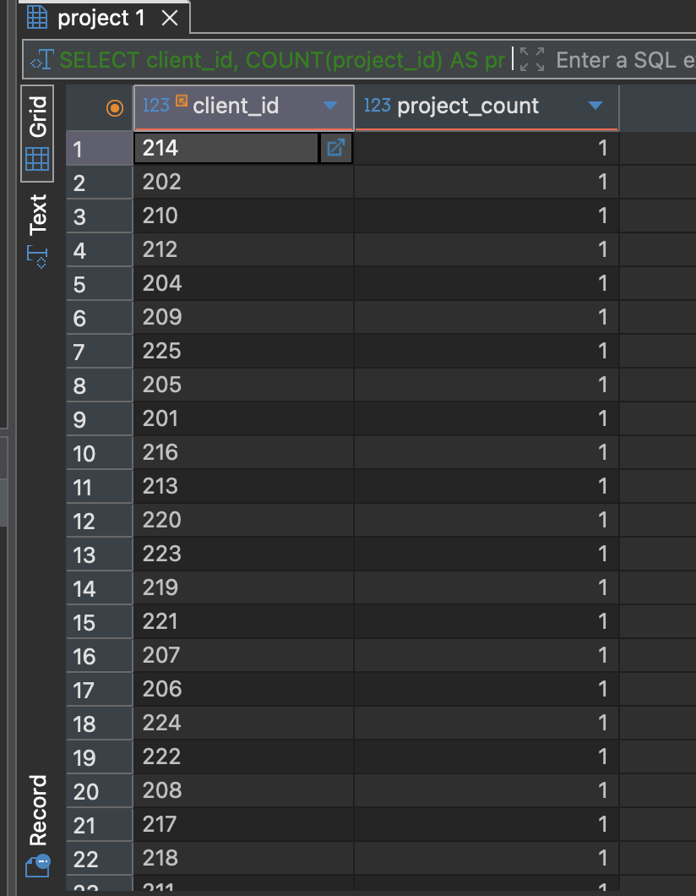

- SELECT dept_id, COUNT(employee_id) AS total_employees
FROM employee
GROUP BY dept_id;

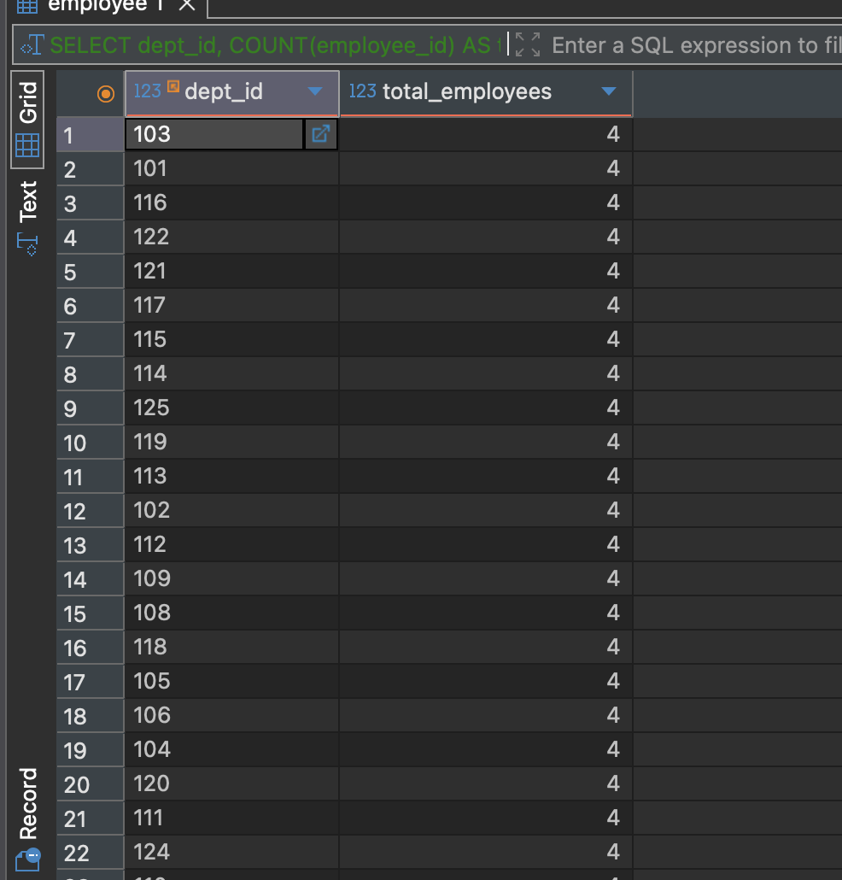

- SELECT
e.employee_fname,
e.employee_lname,
d.dept_name
FROM employee e
JOIN department d
ON e.dept_id = d.dept_id;
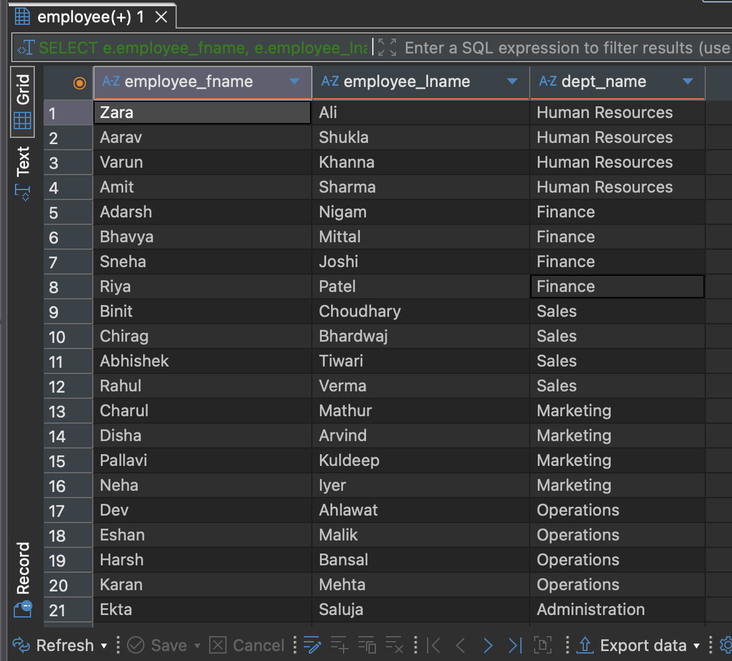

- SELECT
p.project_name,
COUNT(e.employee_id) AS employee_count
FROM project p
JOIN team t
ON p.project_id = t.project_id
JOIN employee e
ON t.team_id = e.team_id
GROUP BY p.project_name;
